Notes on Testing the Validity of the Cleary Orbit Programs
Jim Ball - May 2004
(Revised June 2007)

I. Introduction
Initial attempts to reproduce the extraction experiment runs of 8/16/04 with calculations using the Cleary orbit programs were not successful. The output from these attempts indicated that the calculated fields would not contain protons of the measured energies. The question is therefore raised as to whether or not the Cleary programs provide an accurate representation of the fields produced by the magnet settings used for the extraction runs. To answer this question, the various components of the field settings were examined as detailed in the following report.

II. Reference Data
The calculations for the various field components will be compared against measured field data. Unfortunately, the field data taken in 1977, on which the Cleary programs are based, are no longer available. Instead, the only data available are from the original measurements made in 1971, which are summarized in a series of graphs in an unpublished, preliminary report dated November 30, 1962. The calculations will be compared with the data read from these graphs.

III. The Main Field
The proton extraction runs were made with a main field setting of 1540 amps. Graphs of data from the 1961/62 measurements exist for the settings shown in Table 1. The proton energies listed in this table are taken from page 9 of Log Book 10, dated 7/18/61. However, there is no description in the Log Book about how these proton energies were calculated. The two fields that were initially studied were those at 1490 and 1950 amps, since these bracket the current setting used in the extraction studies and cover the approximate proton energy range of interest for possible improvements.

Table 1.
Main Coil (amps) | Proton Energy
260 | 12
625 | 25
980 | 37
1490 | 50
1950 | 59
2330 | 65
2740 | 70
3220 | 75
3870 | 80

The TCPFIELD code was modified to output values of average field, as a function of radius, to the console. This allows for easy “copy and paste” of the data into MS Excel for analysis and display. This new version of the program was named JBPFIELD. The values of average field, exciting the main coil only, for the 1490 and 1950 field setting are plotted using MS Excel on the next page. The solid curves are the computed output and the points are the values read from the old field measurements. The agreements seem surprisingly good, with the only deviations at small radius. 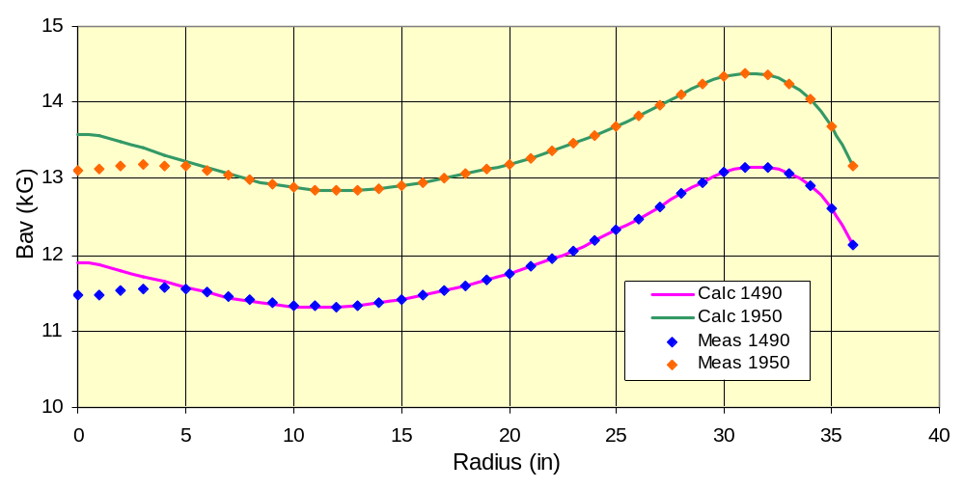The deviations at small radius are expected since the central region was changed about two years after the measurements were made. The rise in the region from 0 to ~6 inches is consistent with the addition of iron plugs to the central region.
The good agreement seen in the main field comparison figure is encouraging that the code may be able to provide an accurate representation of the actual fields present in ORIC. However, only these two fields were checked in detail against the existing field data. As it will turn out later in these studies, the code will have severe problems with lower main field currents.

IV. The Harmonic Coils
The existing data graphs for the harmonic coils are based on measurements with a main field setting of 1950 amps. To calculate the field contribution of these coils, calculations of average field as a function of radius were run for each coil set (harmonic coils 1 through 3, and the valley coils which are also referenced as harmonic coil set 4) with a current of 225 amps of offset current. The contribution of each set was then obtained by taking the difference between these results and the calculation for the main field only case.
The first observation from this analysis was that setting the input current of a harmonic coil set to a positive value results in the calculation producing a field contribution that subtracts from the main field. I.e., a “negative” contribution is obtained. I had always been under the impression that the harmonic coils had been intended to add to the main field and the valley coil intended to subtract from the main field. This impression was supported by the results of the old field measurements which show positive curves for the three harmonic coils and a negative curve for the valley coil. I also remember that at one point there was discussion about making the valley coil positive since the increased flutter was not required. The fact that the calculation shows all of these coil fields to be negative introduces an uncertainty that needs to be resolved.
[NOTE ADDED: Measurements made in 2004 showed that all harmonics and valley coils are configured to subtract from the main filed. See reference 3.]
For the purposes of this study, the currents for calculating the harmonic coils were set to negative so that the resultant fields could be compared directly with the old measurements.
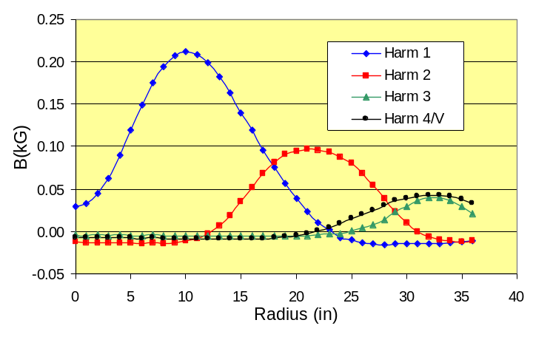
A plot of the calculated contribution to the average field is plotted for each coil in the figure at the right. As noted above, the current for each harmonic coil was set to -225 amps to obtain a positive field. For the purposes of providing a direct comparison, for this figure the current for the valley coil (harmonic 4) was also set to -225 amps.
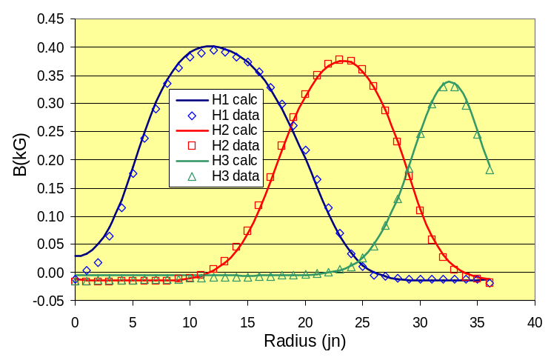
While these results, which represent the contribution of the harmonic coil offset currents to the average field profile, look reasonable, there are no measured data of this type to compare with. The existing data is of the form of radial scans at an azimuth corresponding to the center of an harmonic coil, and azimuthal scans at a radius corresponding to the center of the coil. In order to calculate data in this form that can be easily cut and pasted into Excel, a major rewrite of JBPFIELD was done. This program has been used to generate all of the remaining field calculations discussed in this report.
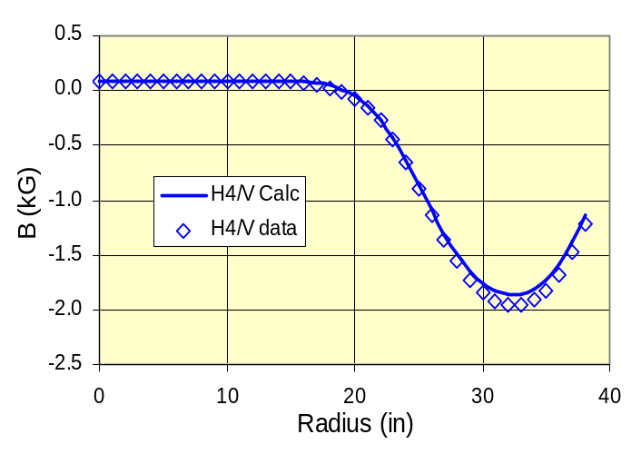
The radial scan calculations for harmonic coils 1 through 3 are compared with the measured data in the figure at the right. The plots are each at an azimuth corresponding to the center of the respective coil (84 deg for H1, 102 deg for H2, and 126 deg for H3). The agreement between calculation and measure data is seen to be quite good.
The only data that is graphed for the valley coil (harmonic 4) is taken at a main field current of 3220 amps with 1820 amps for the valley coil current. The sense of the polarity for the measurements was such that the valley coil contribution subtracted from the main field. A comparison of the calculated radial scan with the measured data is at the right. The agreement is not quite as good as for the other harmonic coils, but is not unreasonable.

V. The Trim Coils
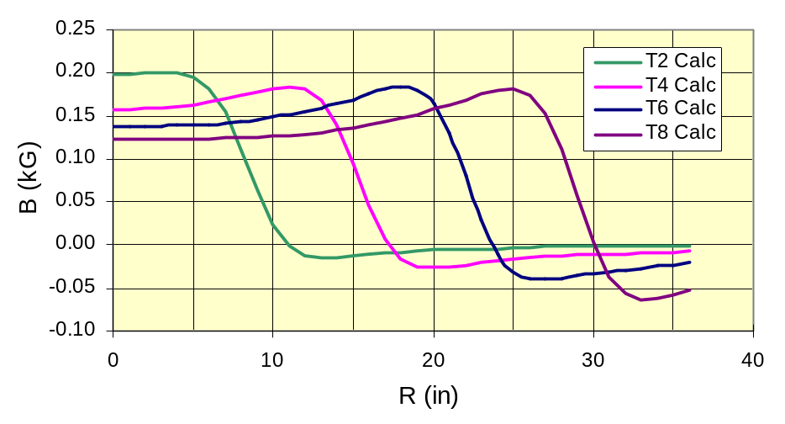
To look at the general behavior of the trim coil fields computed by the program, calculations were made at a main field setting of 1950 amps, for trim coils number 2, 4, 6, and 8 (each, in turn excited with 400 amps). A summary of these results is shown at the right. The first thing to note is that for the trim coils specifying a positive current produces a component of field that adds to the main field (as expected). The second thing to note is that the calculated field contributions are qualitatively in agreement with the measured data.
The graphs available for the measured trim coil data are prepared in a different manner than those for the harmonic coils. For the trim coil data, the graphs plot data for each trim coil taken at main field settings of 980, 2330, and 3870 amps. The trim coil data is plotted in terms of field contribution in gauss per amp. Unfortunately, the graphs are somewhat suspect, since the three fields do not yield results that are monotonic with current. It would appear that the data plotted for the runs at 2330 and 3870 amps have been inadvertently exchanged during the plotting. Also, some of the curve shapes seem a bit suspect and, as I recall, there were some inconsistencies in this original set of trim coil data that prevented fitting the data smoothly as a function of field. This problem is discussed in ORNL Report 3800 (1965) which discusses the remeasurement of this data. Except for a plot in that report of the contribution of each coil at R=0, this data is no longer available.

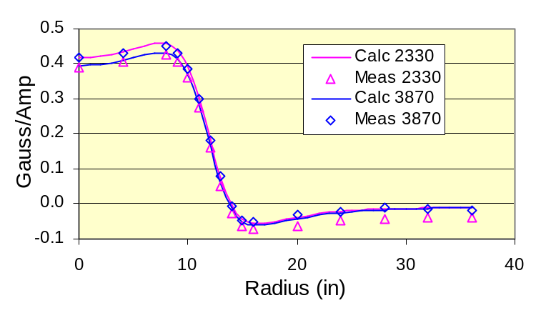
To check the calculations against the existing data, it was decided to run two cases: trim coils number 3 and 6. For these studies, the trim coil currents were set at 500 amps for each of the main field currents. The results from the study of trim coil #3 are shown at the right. The first thing to note is that the results for 980 amps is not included since the calculation gives completely specious results for a main field setting of 980 amps. It would thus appear that the Cleary codes fail as one goes to lower fields. This is explored in more detail in the next section.
The second thing to note from the data above is that the results do indicate that data for the 2330 and 3870 amp runs were reversed in the original data plotting. Except for this, the data does seem to be reasonably well reproduced by the calculations. A notable exception is the data for large radius where the calculations are essentially identical, but the measured results show a discernable difference.
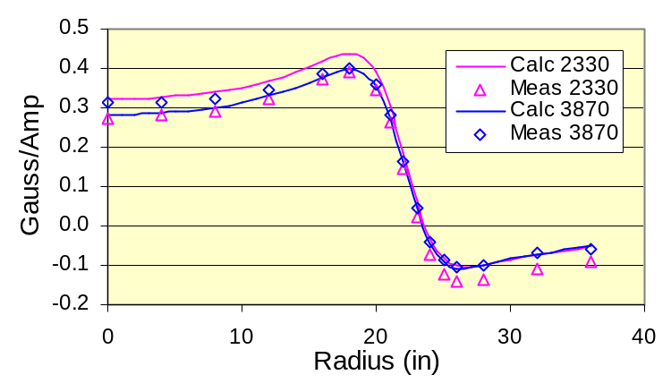
The calculations for trim coil #6 were done only for the 2330 and 3870 amp main field settings and are shown at the right. Again, the experimental data for the two currents are seen to be interchanged in the original report. Here the agreement between calculation and data is not as good, which may be an indicator of the problems encountered with this original data. The two measurements at 2330 amps (labeled 3870 in the original plot) does not show the amount of difference from the other current as seen in the calculations, and in the data set for trim coil #3. Still, the overall agreement is fair, and would seem to indicate that the Cleary program is doing a reasonable job in representing the details of the trim coil contributions.
A later discussion in ORNL Report 4217 (1968) discussed difficulties in using the corrected measurements in field calculations because of the saturation effects seen to decrease the coil contributions as a function of increasing main field. The problem is that each coil adds to the main field, so that the next coil sees a higher field, etc. Thus, one cannot take the main coil field and linearly add all the coil field contribution to it to get the final field shape. The report stressed the need to parameterize the trim coil contributions in term of total magnetic flux rather than main coil current. This scheme evidently resulted in successful calculations of the trim coils to achieve a usable isochronous field. This raises the question of whether this same type of treatment is done within the Cleary program.

To test this last point, calculations of the trim coil contributions for coils 4 through 8 at 400 amps were each calculated individually at a main coil setting of 3870 amps. These were then added to the main coil field to get the “linear addition” field. This “linear addition” field was then compared to the result of the calculation for all of the coils set to 500 amps at a main field of 3870 amps. The difference in the two calculations was fairly small, but is in the correct direction so it could be significant. An examination of Figure 3.2, from ORNL 3800 page 60, shows that at high main fields the change in contribution of the trim coils as a function of field has become rather flat. Thus the change should be rather small, so this seems consistent with the calculated results.
Since Figure 3.2 (ORNL 3800) indicates the expected difference should be larger at lower main fields, the calculations were repeated for a main field setting of 1940 amps and these results are shown on the following page.
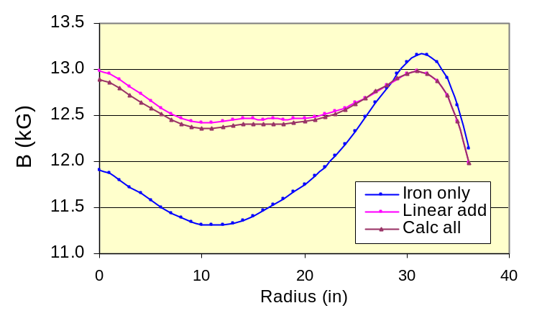
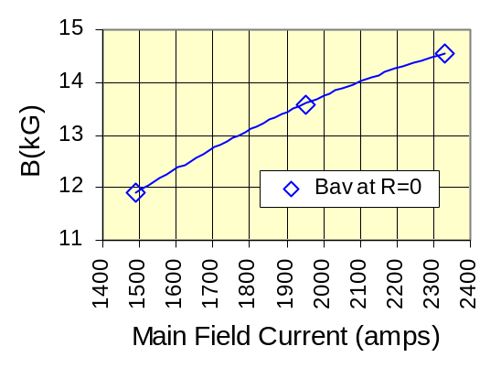
Now the differences in the two methods of calculation are much more obvious, which suggests that the saturation effects are being accounted for in the Cleary programs. To decide if the amount of change seen is reasonable, we can make the following sanity check. From the plot, we see that the average final field at low R is about 1 kG higher than the main coil only field. If we take the value of B_{av} at R=0 for the data sets at 1490, 1950, and 2330 amps, we get the figure at the right. From this we can see that changing the field by 1 kG in the region of 1500 amps will require a change in main field current of about 250 amps. Now from Figure 3.2 in ORNL3800, the change in gauss/amp in the region of 1500 amps is about 0.02 for a 250 amp change around an average value of about 0.35 gauss/amp. Thus the change represents a reduction of about 6% in the contribution of the trim coils to the average field. We would expect that the actual contribution would then be about 6% less than the linear addition result of 1.1 kG, which would be a reduction of about 66 gauss. This compares to the calculated reduction of 88 gauss. Given the approximate nature of the “sanity check,” this “reasonable” agreement would seem to indicate that the saturation effects of the trim coils is being properly accounted for in the Cleary codes.

VI. The Main Field Revisited
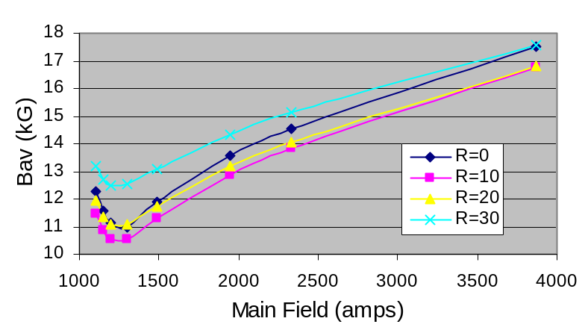
The calculated trim coil results showed the unexpected result that the Cleary codes failed to produce meaningful results for a main field current of 980 amps. The previous main field calculations at 1490 amps (page 2) had shown good agreement with the experimentally measure fields. This raises the question as to the lower limit of validity of the Cleary codes.

The results from calculating the ORIC main field at a number of current settings are plotted at the right. As seen, the behavior of the calculated average field seems reasonable down to about 1300 amps. Below this current, the results show a deviation from the expected trends that signal a problem in the calculations.
If we assume an average extraction radius of 30 inches, and take the field at 1300 amps to be about 12.5 kG, from the figure above, then a rough calculation of the K_{B} for these conditions is 45. Thus, the calculations become suspect below a proton energy of about 45 MeV. While we should be okay for the calculations we are most interested in, which are in the proton energy range of 50 to 60 MeV, future interests at lower energies need to be aware of this limit.

VII. The Lower Channel
One additional question is whether the program accounts for the settings of the coil currents in the compensated iron channel, or whether they simply depend on the coils to be set to the correct balance for the selected main field current. In the studies discussed above, any dependence on lower channel current settings was not obvious. The reason could well have been a lack of sensitivity in those studies to this particular change.
To study this question, the field was calculated for main field only with the inner and outer currents for the lower channel set to the balance conditions as read from the old graph of these settings. To maximize the sensitivity, the calculation was done for only one azimuth that intersected the position of the lower channel. From the drawings of the extraction system elements, an angle of 220 degrees was chosen as being close to the location of the center of the lower channel.
At a main field of 1950 amps, the inner coil current was set at 1460 amps and the outer coil current at 2440 amps. The calculation was run for 220 degrees, and then repeated with the outer coil current changed from 2440 amps to 500 amps. The results show that unbalancing the lower channel coil currents definitely has an effect on the field profile. Thus the program would seem to be compensating for lower channel balance. Whether correctly or not is impossible to tell from the data available.

VIII. Conclusions
The Cleary programs appear to give a good representation of the ORIC magnetic field data, with the limitation that the code should not be used below a main field current of 1300 amps. The programs should be accurate for calculations at higher fields. However, the code cannot be depended on to reproduce the effects of the lower channel at radii beyond 31 inches.

IX. References
1. ORNL Report 3800 (1964). Electronuclear Division Annual Progress Report for Period Ending December 31, 1963, pages 59-61.
2. ORNL Report 4217 (1967). Electronuclear Division Annual Progress Report for Period Ending December 31, 1966, pages 96-99.
3. “Experimental Determination of ORIC Harmonic Coil Polarities,” J. Ball, et al., November 2004 (unpublished). [Available on ORIC Programs CD]

